

Ref: Acapella/EL/26-27/097
Date: 28.08.2026
Sub: Experience Letter
To whomsoever it may concern
This is to certify that Aditya Gupta has successfully completed his internship with Acapella Productions as a Database Management Intern from May 01, 2026 to July 31, 2026.
During the internship period, Aditya demonstrated exceptional technical skills, professionalism, and a strong aptitude for problem-solving and innovation. He was primarily responsible for assistance in managing database records, optimizing queries, and assisting with data organization, proving to be efficient, reliable, and highly effective in achieving the intended goals.
During this tenure, we found him very sincere, creative, and hardworking. This is to confirm that he has been relieved from all his responsibilities and holds no dues towards the company.
We take this opportunity to thank him and wish him success in his future endeavours.
Warm regards,

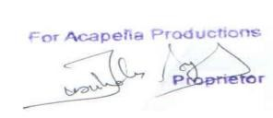
Authorized Signatory Acapella Productions

